# StormNet 2018

This year’s StormNet builds on the prior year’s capabilities and improves many of the design hurdles previously faced. At its core, an Arduino Mega offers ample code storage, input/output pins, and coding simplicity. New for 2018 is an *enhanced* I2C bus providing long-range, high-speed communications between the Mega and up to 64 remote sensor nodes. The sensor node of choice this year is a small LiDAR module capable of precisely measuring distances from 20mm to 3 meters in under 30ms.

## Pre-season prep

Throughout the pre-season (June-December), mentors Bill Kazman and Jon Eggert offered a series of electronics workshops (aka, eLabs). Students were encouraged to attend each workshop an asked only to bring a laptop and desire to learn.

## eLabs 1-4 – Oct - Dec 2017 – Intro to ESP32 and Arduino

This eLab introduced students to the basic development environment, coding language, and hardware capabilities of microcomputers (MCUs). Stormgears provided every student with a new Espressif ESP32 DEVKIT-C MCU, solderless breadboard, hookup wires, a NeoPixel, and access to a variety of resistors, capacitors, switches, potentiometers, and the like.

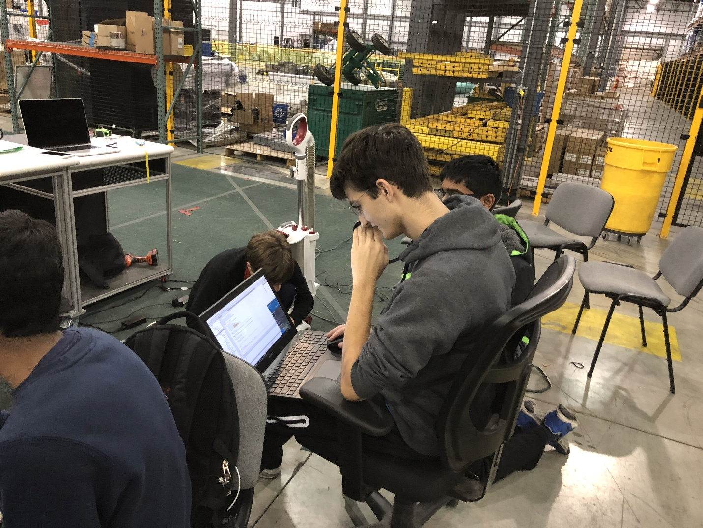

The journey began with installing and configuring the Arduino IDE with support for the ESP32. After installing the software, students learned the basics of creating a simple “Hello world” sketch, compiling the code, and flashing it to the device. Next, we focused on lighting a standard LED, then a neopixel, EL wire, and even turning a motor with a single H-bridge. Many students took each challenge a step further coming up with their own code to dim the LED, make the motor run in reverse, or respond to sensory inputs such as touch, IR reflections, and LiDAR distance measurements.

Toward the end of our eLab series, we asked the students to brainstorm and select a project they can complete prior to the first competition. We provided a list of constraining factors such as cost, available sensors, and output options such as LEDs, and motors. We broke the room up into 4 teams and gave them 30 minutes with a whiteboard to map out their projects. Each project had one of three outcomes: 1. Something wearable – ie., a cool tech gadget students can wear at competitions. Concepts ranged from full head to toe EL wire to flashing lightning bolts designed to respond differently depending on how many other Stormgears members were nearby. 2. A giveaway – Something, cool, small, inexpensive, and easy to make. Student designed concepts included buttons with flashing LEDs and light-up bracelets. 3. A kinetic sculpture celebrating STEM to spruce up the pit. Students brainstormed ways to turn gears and autonomously control movement of ping-pong balls.

The outcome of the eLab training was a set of prototype circuits and software demonstrating student control of each kind of available sensor, LED, and motor. These breadboarded circuits became the foundation of StormNet’s final design.

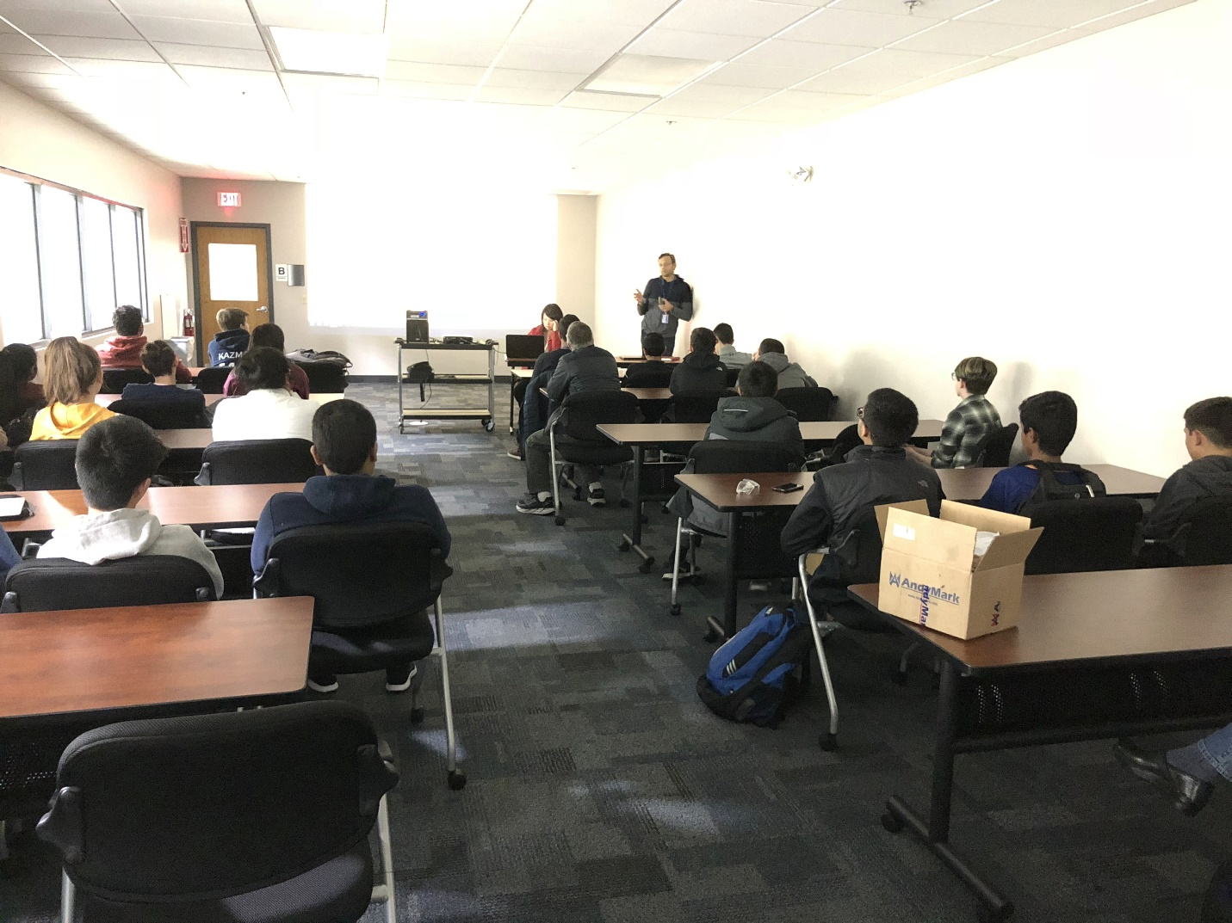

## SolidWorks Training – Nov 2017 – 3D CAD, Schematic Capture, and PCB Layout

Our sponsor, SolidWorks, provided two days of training at our facility in Devens. Students received the student edition of SolidWorks 2017 CAD and PCB.

One the first day, professional trainers walked students through designing simple shapes, then creating a useful box with a lid. Students then learned to export their 3D model, slice it for printing, and send it to our 3D printer.

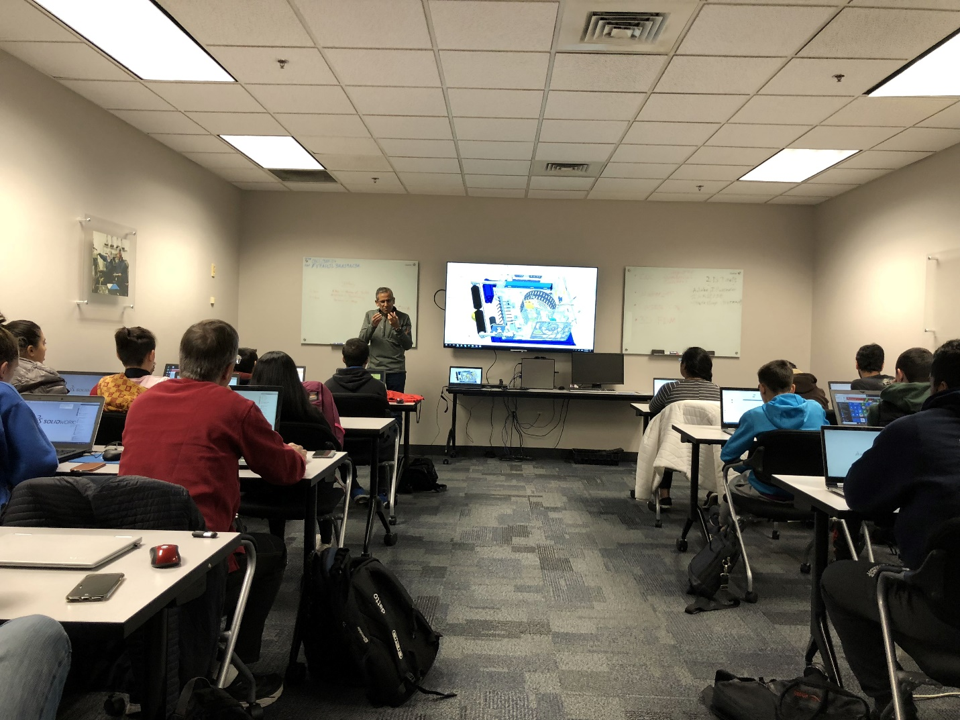

The second day focused on schematic capture and PCB layout. Students converted their breadboard prototypes into engineering schematics and ultimately simple printed circuit board designs.

## Introducing StormNet v2 2018

With the bulk of the design work completed before season kickoff, students and mentors came to an agreement on what capabilities StormNet must support to meet our season goals. Students gathered their favorite circuit designs and sample Arduino code. Each circuit combined into a single schematic supporting the desired functionality. After PCB layout was completed, an order for professionally made PCBs provided the platform to see the team’s work come together in a commercial-grade product.

